**PRACTICE SET**

mysql> create database salesman;

Query OK, 1 row affected (0.35 sec)

mysql> use salesman;

Database changed

mysql> create table salesman(sid int,name varchar(40),city varchar(50),commition float);

Query OK, 0 rows affected (1.29 sec)

mysql> desc salesman;

+-----------+-------------+------+-----+---------+-------+

| Field | Type | Null | Key | Default | Extra |

+-----------+-------------+------+-----+---------+-------+

| sid | int | YES | | NULL | |

| name | varchar(40) | YES | | NULL | |

| city | varchar(50) | YES | | NULL | |

| commition | float | YES | | NULL | |

+-----------+-------------+------+-----+---------+-------+

4 rows in set (0.43 sec)

mysql> insert into salesman values(5001,'James Hoog','New York',0.15),

-> (5002,'Nail Knite','Paris',0.13),

-> (5005,'Pit Alex','London',0.11),

-> (5006,'Mc Lyon','Paris',0.14),

-> (5007,'Paul Adam','Rome',0.13),

-> (5003,'Lauson Hen','San Jose',0.12),

-> (5008,'Rose Willy','NULL',0.17),

-> (5009,'Lauson Hen','Itly',NULL);

Query OK, 8 rows affected (0.14 sec)

Records: 8 Duplicates: 0 Warnings: 0

mysql> select * from salesman;

+------+------------+----------+-----------+

| sid | name | city | commition |

+------+------------+----------+-----------+

| 5001 | James Hoog | New York | 0.15 |

| 5002 | Nail Knite | Paris | 0.13 |

| 5005 | Pit Alex | London | 0.11 |

| 5006 | Mc Lyon | Paris | 0.14 |

| 5007 | Paul Adam | Rome | 0.13 |

| 5003 | Lauson Hen | San Jose | 0.12 |

| 5008 | Rose Willy | NULL | 0.17 |

| 5009 | Lauson Hen | Itly | NULL |

+------+------------+----------+-----------+

8 rows in set (0.00 sec)

**1.Write a SQL statement that displays all the information about all salespeople.**

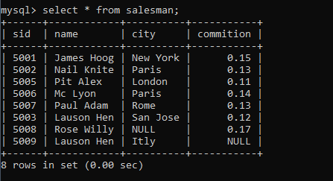

**2. Write a SQL statement to display specific columns such as names and commissions for all salespeople.**

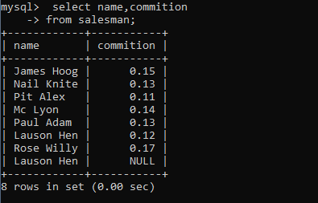

**3. write a SQL query to locate salespeople who live in the city of 'Paris'. Return salesperson's name, city.**

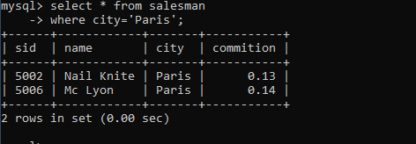

**4.write a SQL query to locate salespeople who live in the city of 'San Jose'. Return salesperson's name, commission.**

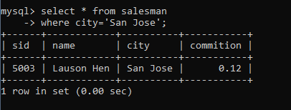

**5.Write a SQL statement to display columns such as salesman_id ,names and city for all salespeople.**

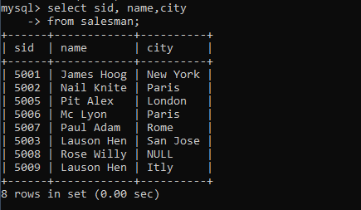

**7.Write a SQL statement that displays all the information Arranged the output in ascending order by name.**

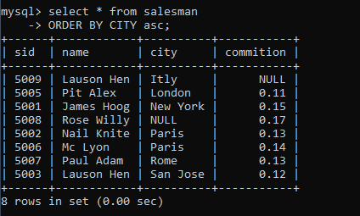

**8.Write a SQL statement that displays all the information Arranged the output in ascending order by salesman_id**

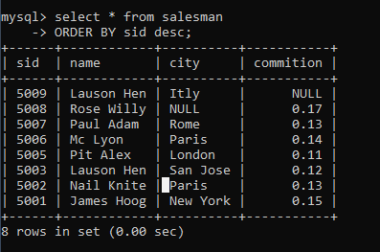

**9.Write a SQL statement that displays all the information Sort the output in descending order on salesman_id.**



**10.Write a SQL statement that displays all the information who live in the city of 'San Jose' AND 'Paris' Sort the output in descending order on salesman_id.**

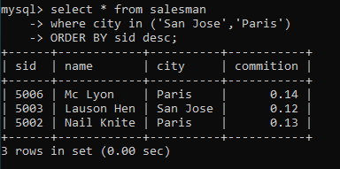

**11.write a SQL query to locate who live in the city of 'San Jose' AND 'Paris' Sort the output in ascendingorder on salesman_id.**

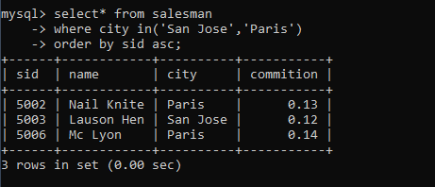

**12.Write a SQL statement who live in the city of 'San Jose' AND 'Paris' Sort the output in descending order on name**

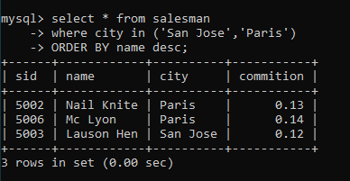

**13.write a SQL query to locate who live in the city of 'Rome' OR'London' Sort the output in ascending order on salesman_id.**

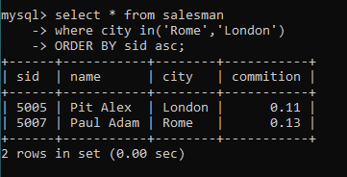

**14.write a SQL query to locate who live in the city of 'New York' OR'London' Sort the output in ascending order on city .**

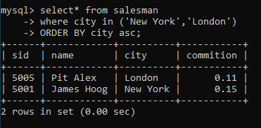

**15.write a SQL query to locate who live in the name of 'James Hoog' OR 'Paul Adam' Sort the output in ascending order on commission.**

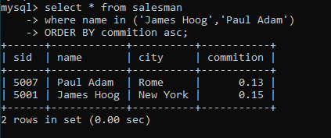

**16.Write a SQL statement to display specific columns such as names and commissions,city for all salespeople having commission 0.13.**



**17.Write a SQL statement to display specific columns such as names and commissions for all salespeople having commission greater than 0.12.**

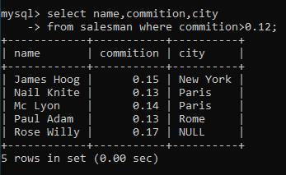

**18.Write a SQL statement to display all salespeople having commission greater than 0.12.**

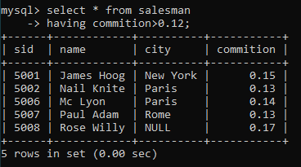

**19.Write a SQL statement that displays all the information salespeople having city is NULL.**

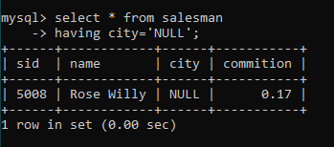

**20.Write a SQL statement that displays all the information salespeople having commission is NULL.**

